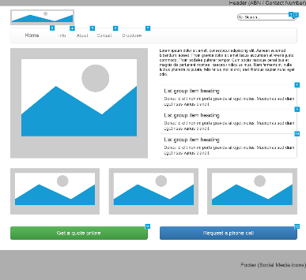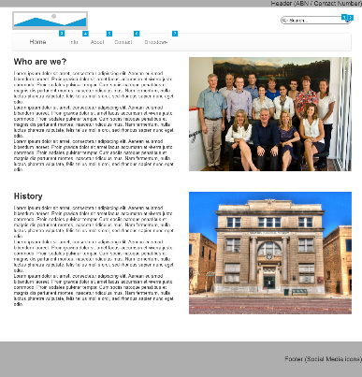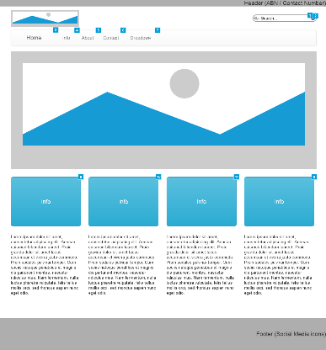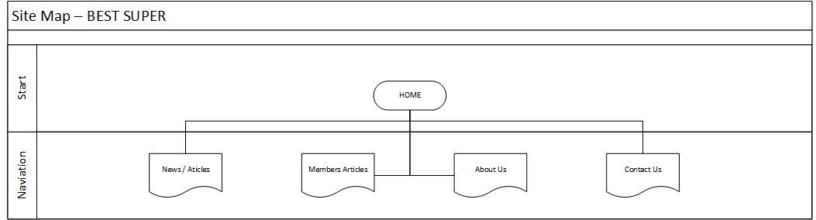

Sitemap

User Persona

Wire Frames

Design Rationale

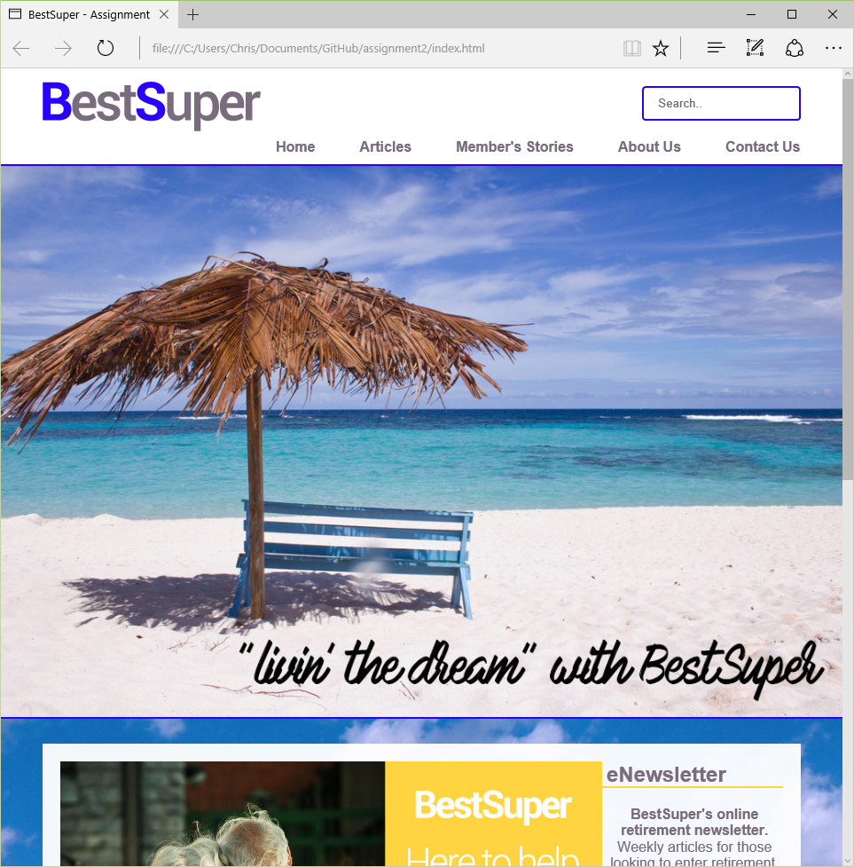

The design for **BestSuper** was targeted towards people looking to enter retirement or those just beginning retirement, so the design was kept simple and uncluttered.

**Consistent Navigation –** consistent headings and menu options throughout the site. The same font was used throughout the site to further support this concept of consistency.

**Large “hero” image** – usedfor the desktop version of the site, but removed for the mobile application. Photographs of tropical destinations / holidays used to appeal to the target audience.

**Current trending articles displayed on home page** – most recent / popular article featured on the home page, with intentions of this updating once every 24hrs to keep the site active.

**Minimal text on main pages** – to keep with a simplified design, the home page is restricted to minimal content. Large images and short text lines used to entice the user to continue further into the site.

**Maximum of 3 scrolls on main pages** – more than 3 scrolls has been proven to be a deterrent to users.

Age: 70

Occupation: Retired

Relationship Status: Married

Location: Australia

**GOALS**

* User has commenced retirement and is searching for a source of information to secure their lifestyle and ensure stability for the future.
* User is looking for information from a reputable source.

**FRUSTRATIONS**

* Previous attempts have been time consuming and difficult, as many other sites offer a broad range of information, user is looking for a source that is specific to their needs and current situation.

**4 Colours** – complimentary colours used throughout the site (blue, yellow, grey. White).

**User focused content** – all content on the site is written to be of interest to the target audience. Articles are intended to be a starting point for those looking for support or advice with their current situation.

**Responsive Design** – a mobile version of the site is offered when the frame is less than 600px wide. The design is similar, but with the removal of large images to improve loading times and an easier accessible menu option.

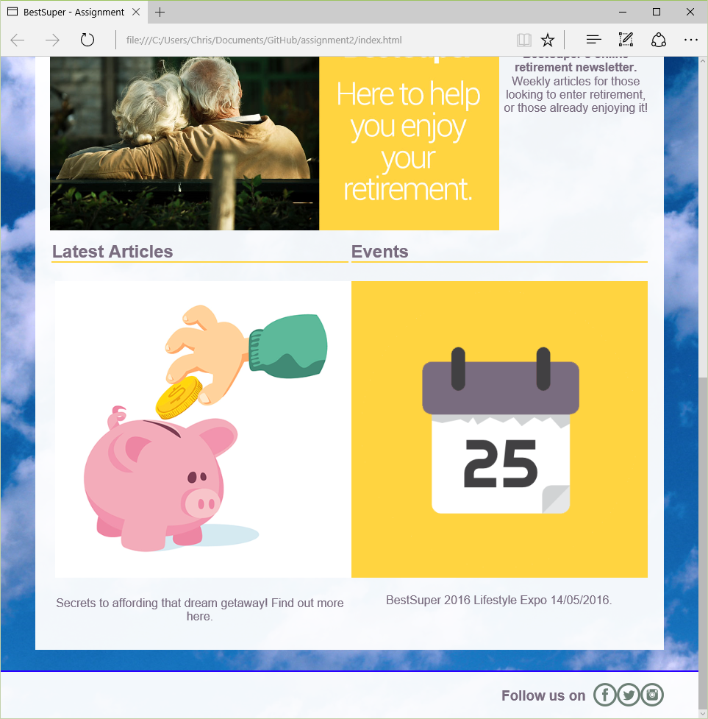

CHRIS KELLY – n8102597